# **POSITIONING**

# **Task 1**

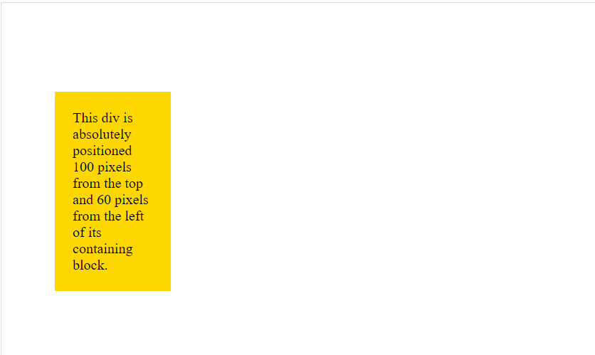Task 2

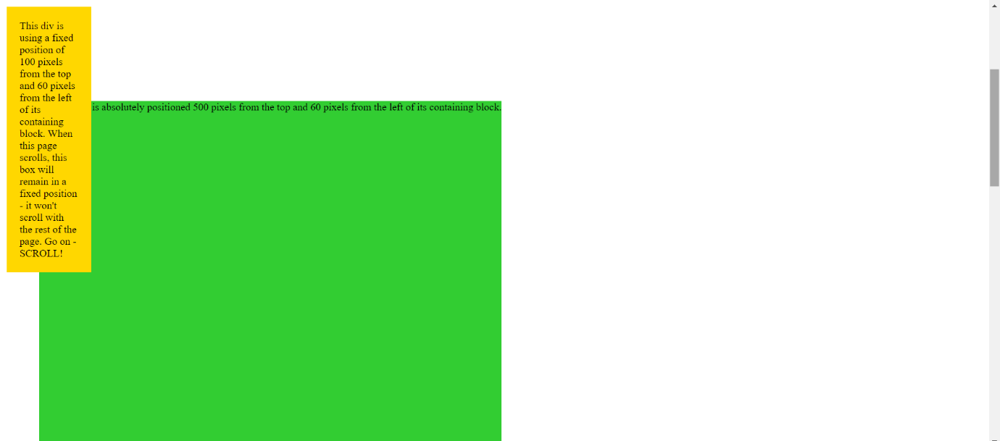

CSS LIST

Task 1:

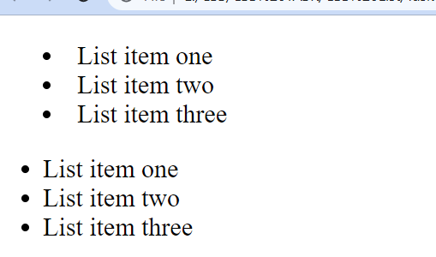

CSS FLOAT

Task 1:

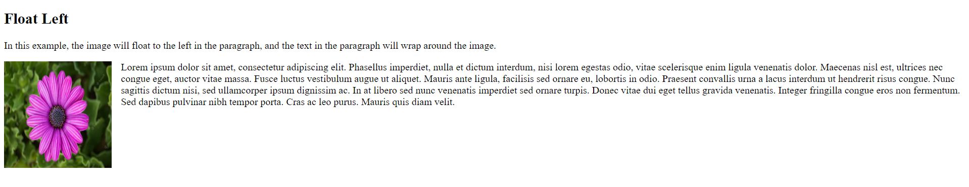

CSS TRANSFORM

TASK 1:

Moves the <div> element 50 pixels to the right, and 100 pixels down from its current position

TASK 2:

Rotates the <div> element clockwise with 20 degrees

TASK 3:

Rotates the <div> element counter-clockwise with 20 degrees:

TASK 4:

Increases the <div> element to be two times of its original width, and three times of its original height

TASK 5:

Increases the <div> element to be two times of its original width

 TASK 6:

Skews the <div> element 20 degrees along the X-axis

CSS PSUEDO ELEMENT

Task2: 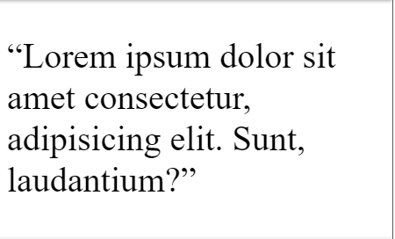

Task 1:

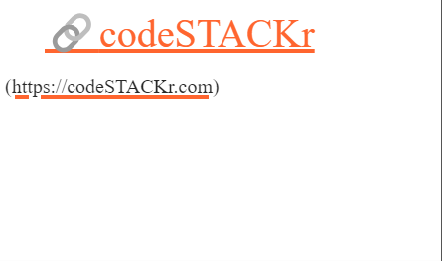

CSS FONTS

Create (or re-use) an HTML Document of your choosing and then incorporate 2-3 Custom Google Fonts into the page.

# **Box model**

## Task 1

In this task, there are two boxes below, one is using the standard box model, the other the alternate box model. Change the width of the second box by adding declarations to the .alternate class, so that it matches the visual width of the first box.

Your final result should look like the image below:

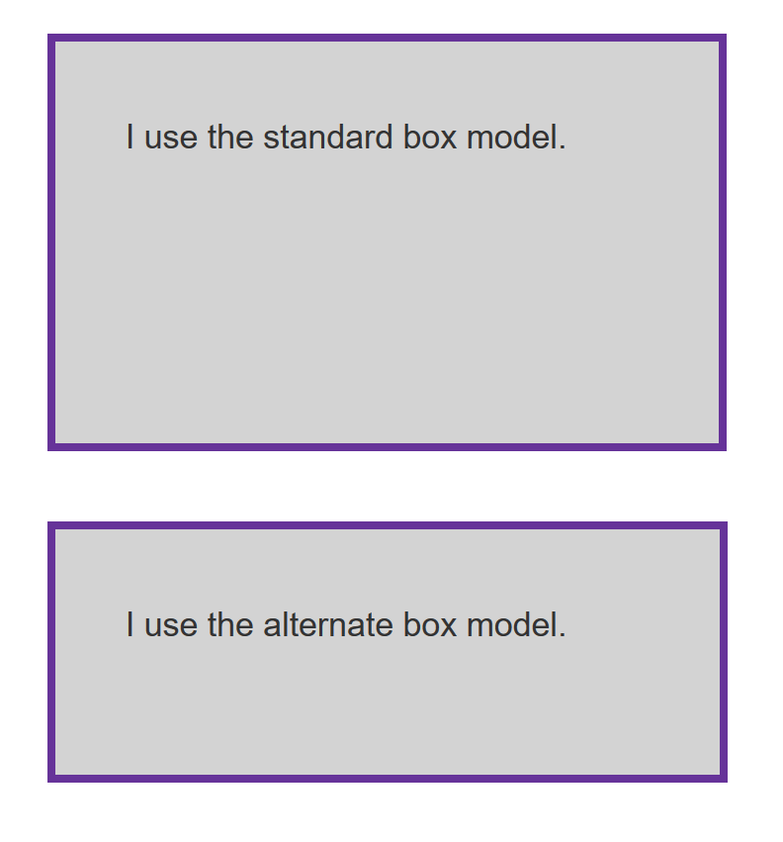

**Task 2**

In this task, add to the box:

* A 5px, black, dotted border.
* A top margin of 20px.
* A right margin of 1em.
* A bottom margin of 40px.
* A left margin of 2em.
* Padding on all sides of 1em.

Your final result should look like the image below:

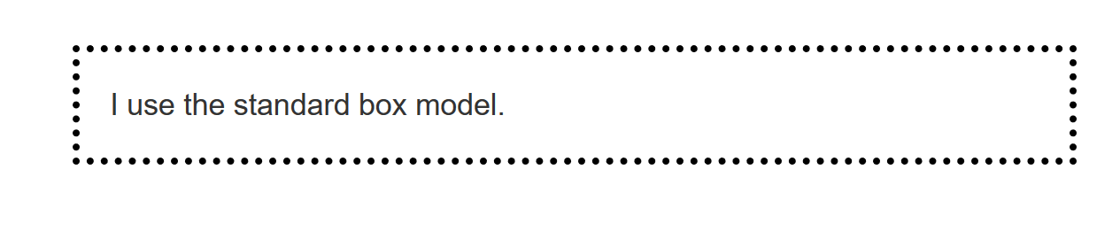

## Task 3

In this task, the inline element has a margin, padding and border. However, the lines above and below are overlapping it. What can you add to your CSS to cause the size of the margin, padding, and border to be respected by the other lines, while still keeping the element inline?

Your final result should look like the image below:

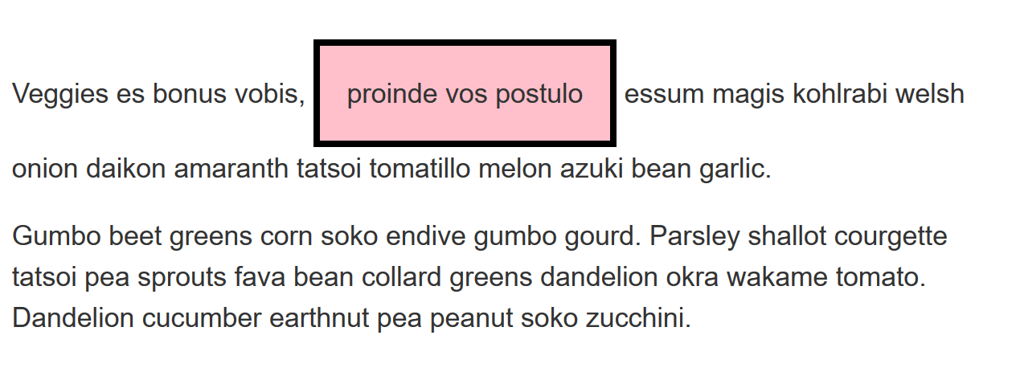

CSS FLEXBOX

## Task 1

In this task, the list items are the navigation for a site. They should be laid out as a row, with an equal amount of space between each item.

Your final result should look like the image below:



Try updating the live code below to recreate the finished example:

## Task 2

In this task, the list items are all different sizes, but we want them to be displayed as three equal sized columns, no matter what content is in each item.

Your final result should look like the image below:

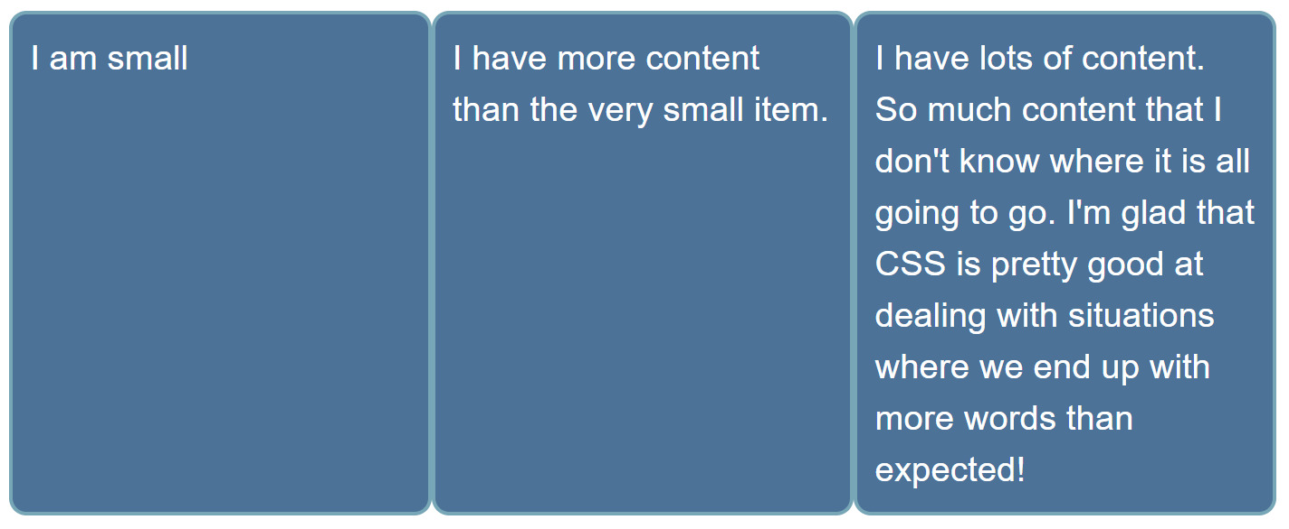

## Task 3

Your final result should look like the image below:

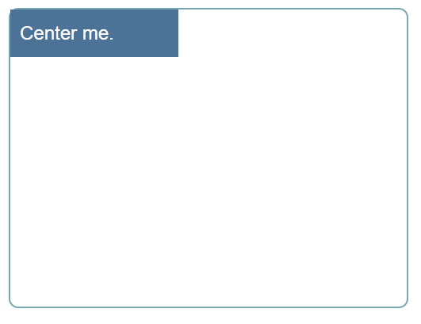

Task 4:

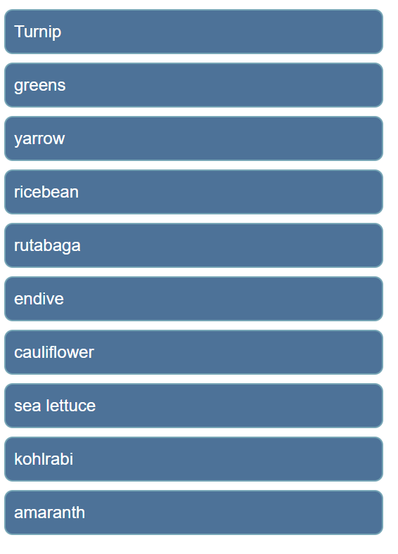

CSS GRID

Task 1:

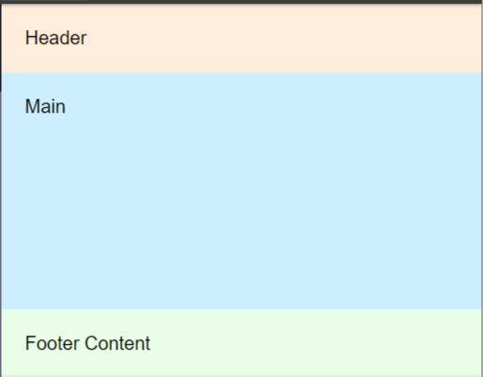

Task 2:

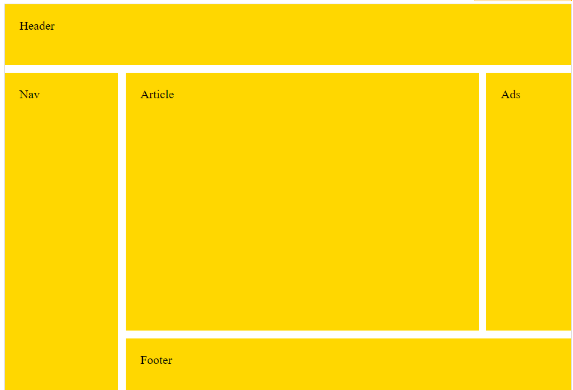

CSS MEDIA QUERIES

**TASK 1:**

**Change color**

**Task 2:**

**Width of Column**

**Task 3:**

**Change colors for multiple Devices**

CSS ANIMATION

